# Details.

* A Quiz Application tests the user to solve MCQ exams in the programming field, send messages to admin, open URL social media and view total score.
* A Quiz Application create quizzes, view / delete messages, view / delete quizzes, view user details in system.

Login

Set username and password to login or

Sign UP

To sign Up set ( name, Username, Email, Phone, Password ).

- Home page (ADMIN).

- Total User in System.

- Total Quizzes in System.

- Total completed Quizzes.

- Table User ( ID, Name, Username, Email, Phone, Score ).

- Box Messages ( name, small TextOfMessage ).

- Button User.

- Search User By USERNAME.

- Table User ( ID, Name, Username, Email, Phone, Score ).

-Button Quizzes.

- Search Quiz By TAG.

- Table QUIZ ( ID, Name, Tag, Details).

-Button Messages.

- Search Message by ID.

- Table Message ( ID, Name, Email, Phone, Text).

-Button Setting.

- Update

Name, Username, Email, Phone, Password

Facebook, GitHub, Twitter, YouTube.

-Button AddQuiz.

- Add Quiz.

( Name, Tag, Details, Questions [Question, Choses] ).

- Button Logout.

- Home page (USER).

- Total Quizzes in System.

- Total Tags in System.

- Contact Us (Facebook, GitHub, Twitter, YouTube).

- Button My Profile.

- View ( Name, Username, Email, Phone, Score)

- Button Quizzes or Let’s GO.

- Select any Quiz to do Quiz.

- Button Start.

- Next Questions.

- Close Quiz.

- Button Send Message.

- To send message set

( Name, Email, Phone, Text ).

- Button Setting.

- Update

Name, Username, Email, Phone, Password

# Functional Requirements.

|  |  |
| --- | --- |
| **Admin login** | admin can enter username and password to access admin frame. |
| **View Users** | Admin can see all users in the system. |
| **Add Quizzes** | Admin can see app quizzes in the system. |
| **View Quizzes** | Admin and User can see all quizzes in the system. |
| **Delete Quizzes** | Admin can delete any quiz in the system. |
| **View Messages** | Admin can see all Messages in the system. |
| **Delete Messages** | Admin can delete any Messages in the system. |
| **Update profile** | The system shall allow “ Admin / User ” to update their profile. |
| **View profile** | The system shall allow “ Admin / User ” to view their profile. |
| **User Registration** | The system allows the user to sign up for the first time by entering a name, E-mail, username, phone, and password. |
| **User login** | The system allows the user to log in with username and password to search. |
| **Send Messages** | User can send message to admin in the system. |
| **Do Quiz** | User can do quiz in the system |
| **View Score** | The system shall allow “ User ” to view their scores. |
| **Contact Us** | The system shall allow “ User ” to contact us. |

# Non - functional Requirements.

* **Security:**

Security requirement is very important in this project, including privacy. The administrator should provide high security interface for user and protect their personal data.

There should be proper security regarding to the accessing of data by unauthorized user.

* **Performance:**

The performance of the functions and every module should be well.

The system operates its functions in a small amount of time which is less than two second.

* **Usability:**

The system is very simple, has friendly user interface and easy for users to interact with it.

* **Availability:**

The system will be available to its users at any time whenever they want.

The system shall have its expected downtime announced at least 48 hours in advance.

* **Evolvability:**

The system shall be easily extensible and evolvable.

* **Maintainability:**

Users can connect to each in the system.

The system shall be easily maintainable.

* **Correctness:**

The results of the function should be pure and accurate by validating or testing the system.

* **Portability:**

The software shall be deployed at any machine.

* **Reusability:**

The data and record that are saved shall be reused if needed that is stored in backup.

* **Quality Control:**

This system shall save the time for all users.

# Use-Case Diagram(s).

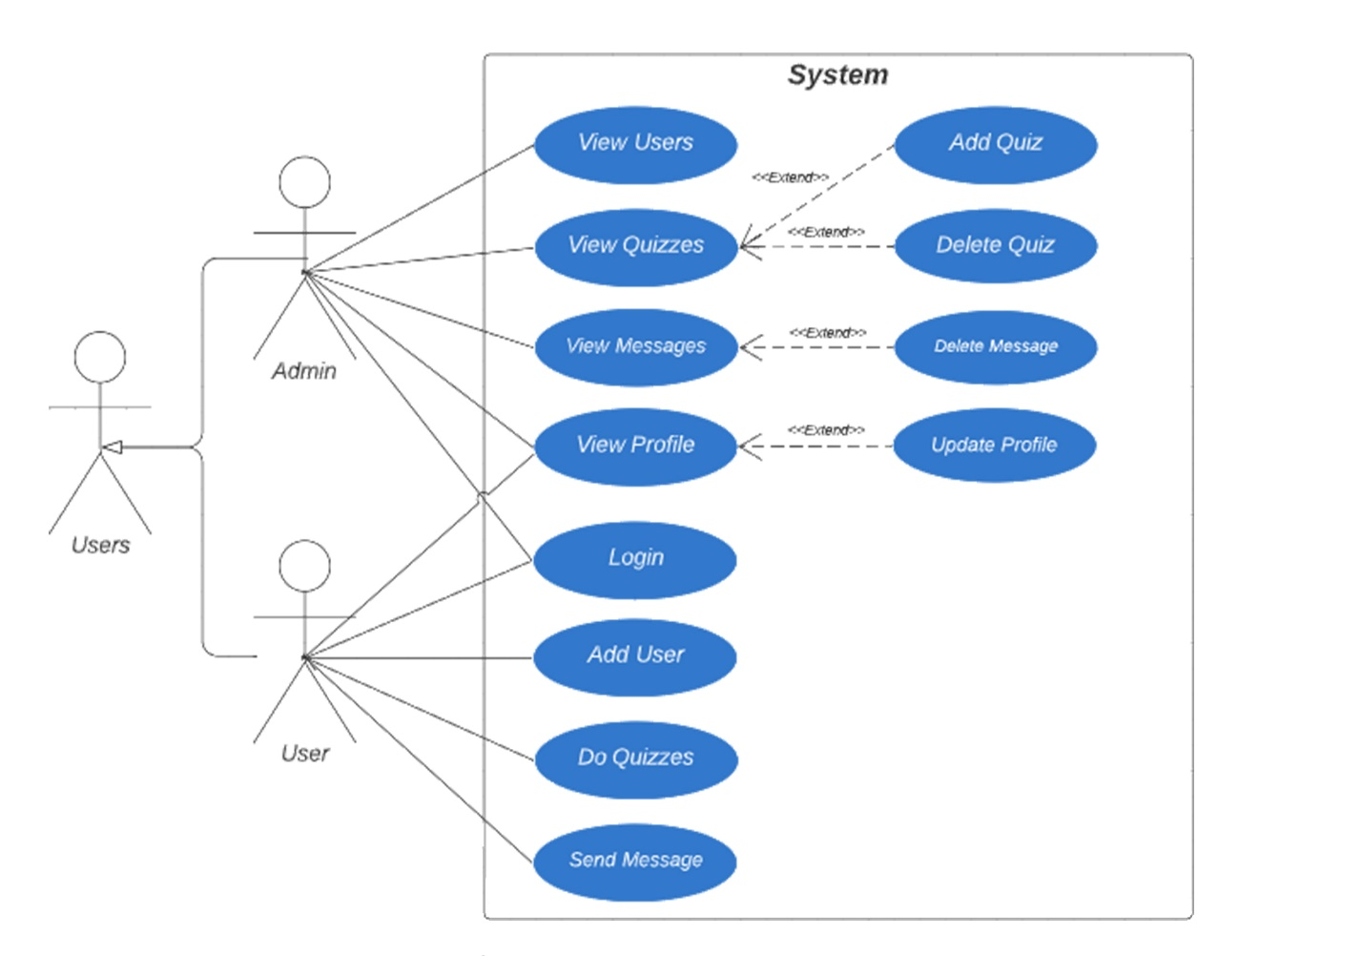

**Use case:** Login.

**Initiator:** Admin/User

**Goal:** Login into the application.

**Pre-condition:** The Admin must write the correct username and the matching password to access the admin frame, The User must write the correct username and the matching password to access the user frame.

**Scenario:**

Checks if the Admin/User is eligible to get admission in the application.

Provide a form to the Admin/User to get the right data from them.

Check if the Admin/User fills the form correctly.

Save the information of Admin/User and is Signed in.

Log in the application.

**Post-condition: The Admin/User will login the application correctly.**

**Use case:** Add User.

**Initiator:** User.

**Goal:** Add new user in the app and make changes to Users records.

**Pre-condition:** The User must be eligible and has the right data(users must fulfill the requirements to get admission).

**Scenario:**

Check if the user is eligible and has the right data.

Provide a form to the user to get his/her data.

Check if the user fills the form correctly.

Save the information of user and user is added.

Edit the existing information and update any change is made.

**Post-condition: The User will be added correctly.**

**-------------------------------------------------------------------------------------------------------------------------**

**Use case:** Add Quiz.

**Initiator:** Admin

**Goal:** Add new quiz in the app and make changes to quiz records.

**Pre-condition:** The Admin logged in the application and made sure that he had the right questions and the right answers.

**Scenario:**

**The admin adds a new quiz, name, tag, and details.**

**The admin adds the questions.**

**The admin adds the Choices.**

**The admin adds the Answers.**

**Post-condition: The Admin will add the Quiz correctly.**

**Use case:** Delete Quiz.

**Initiator:** Admin

**Goal:** Delete quiz in the app and make changes to quiz records.

**Pre-condition:** The Admin logged in the application and made sure that he had selected the specified quiz that he/she wanted to delete.

**Scenario:**

**- The admin selects a quiz and delete it.**

**Post-condition: The Admin will delete the Quiz correctly.**

**-------------------------------------------------------------------------------------------------------------------------**

**Use case:** Delete Message.

**Initiator:** Admin

**Goal:** Delete message in the app and make changes to message records.

**Pre-condition:** The Admin logged in the application and made sure that he had selected the specified message that he/she wanted to delete.

**Scenario:**

**- The admin selects a message and delete it.**

**Post-condition: The Admin will delete the Message correctly.**

**-------------------------------------------------------------------------------------------------------------------------------**

**Use case:** Send Message.

**Initiator:** User.

**Goal:** send new message in the app and make changes to message records.

**Pre-condition:** The User logged in the application and made sure that he had selected the specified message that he/she wanted to send.

**Scenario:**

**- The User will send the text message in the application.**

**Post-condition: The User will send the message correctly.**

**Use case:** Do Quizzes.

**Initiator:** User.

**Goal:** Solve the quiz.

**Pre-condition:** The User must log in the application and view the quizzes sector and selected a quiz.

**Scenario:**

The User views the quizzes page

The User selects a quiz

The User chose and submitted questions

The User checks the answers of the quiz

**Post-condition: The Quiz will be Solved correctly.**

**-------------------------------------------------------------------------------------------------------------------------------**

**Use case:** Update.

**Initiator:** Admin/User.

**Goal:** Update data in the Profile page.

**Pre-condition:** The Admin/User must log in the application and hit to the profile page.

**Scenario:**

The Admin/User must have the right data to be edited

The Admin/User must follow the rules for the right configuration

**Post-condition: The Admin/User profile will be updated correctly.**

**Use case:** Login.

**Initiator:** Admin/User

**Goal:** Login into the application.

**Pre-condition:** The Admin must write the correct username and the matching password to access the admin frame, The User must write the correct username and the matching password to access the user frame.

**Scenario:**

Checks if the Admin/User is eligible to get admission in the application.

Provide a form to the Admin/User to get the right data from them.

Check if the Admin/User fills the form correctly.

Save the information of Admin/User and is Signed in.

Log in the application.

**Post-condition: The Admin/User will login the application correctly.**

**----------------------------------------------------------------------------------------------------------------------**

**Use case:** Add User.

**Initiator:** User.

**Goal:** Add new user in the app and make changes to Users records.

**Pre-condition:** The User must be eligible and has the right data(users must fulfill the requirements to get admission).

**Scenario:**

Check if the user is eligible and has the right data.

Provide a form to the user to get his/her data.

Check if the user fills the form correctly.

Save the information of user and user is added.

Edit the existing information and update any change is made.

**Post-condition: The User will be added correctly.**

**Use case:** Add Quiz.

**Initiator:** Admin

**Goal:** Add new quiz in the app and make changes to quiz records.

**Pre-condition:** The Admin logged in the application and made sure that he had the right questions and the right answers.

**Scenario:**

**The admin adds a new quiz, name, tag, and details.**

**The admin adds the questions.**

**The admin adds the Choices.**

**The admin adds the Answers.**

**Post-condition: The Admin will add the Quiz correctly.**

**---------------------------------------------------------------------------------------------------------------------------**

**Use case:** Delete Quiz.

**Initiator:** Admin

**Goal:** Delete quiz in the app and make changes to quiz records.

**Pre-condition:** The Admin logged in the application and made sure that he had selected the specified quiz that he/she wanted to delete.

**Scenario:**

**- The admin selects a quiz and delete it.**

**Post-condition: The Admin will delete the Quiz correctly.**

**Use case:** Delete Message.

**Initiator:** Admin

**Goal:** Delete message in the app and make changes to message records.

**Pre-condition:** The Admin logged in the application and made sure that he had selected the specified message that he/she wanted to delete.

**Scenario:**

**- The admin selects a message and delete it.**

**Post-condition: The Admin will delete the Message correctly.**

**-------------------------------------------------------------------------------------------------------------------------------**

**Use case:** Send Message.

**Initiator:** User.

**Goal:** send new message in the app and make changes to message records.

**Pre-condition:** The User logged in the application and made sure that he had selected the specified message that he/she wanted to send.

**Scenario:**

**- The User will send the text message in the application.**

**Post-condition: The User will send the message correctly.**

**------------------------------------------------------------------------------------------------------------------------------**

**Use case:** Do Quizzes.

**Initiator:** User.

**Goal:** Solve the quiz.

**Pre-condition:** The User must log in the application and view the quizzes sector and selected a quiz.

**Scenario:**

The User views the quizzes page

The User selects a quiz

The User chose and submitted questions

The User checks the answers of the quiz

**Post-condition: The Quiz will be Solved correctly.**

**-------------------------------------------------------------------------------------------------------------------------------**

**Use case:** Update.

**Initiator:** Admin/User.

**Goal:** Update data in the Profile page.

**Pre-condition:** The Admin/User must log in the application and hit to the profile page.

**Scenario:**

The Admin/User must have the right data to be edited

The Admin/User must follow the rules for the right configuration

**Post-condition: The Admin/User profile will be updated correctly.**

# Activity Diagram(s).

# Database Specification (ERD, Tables).

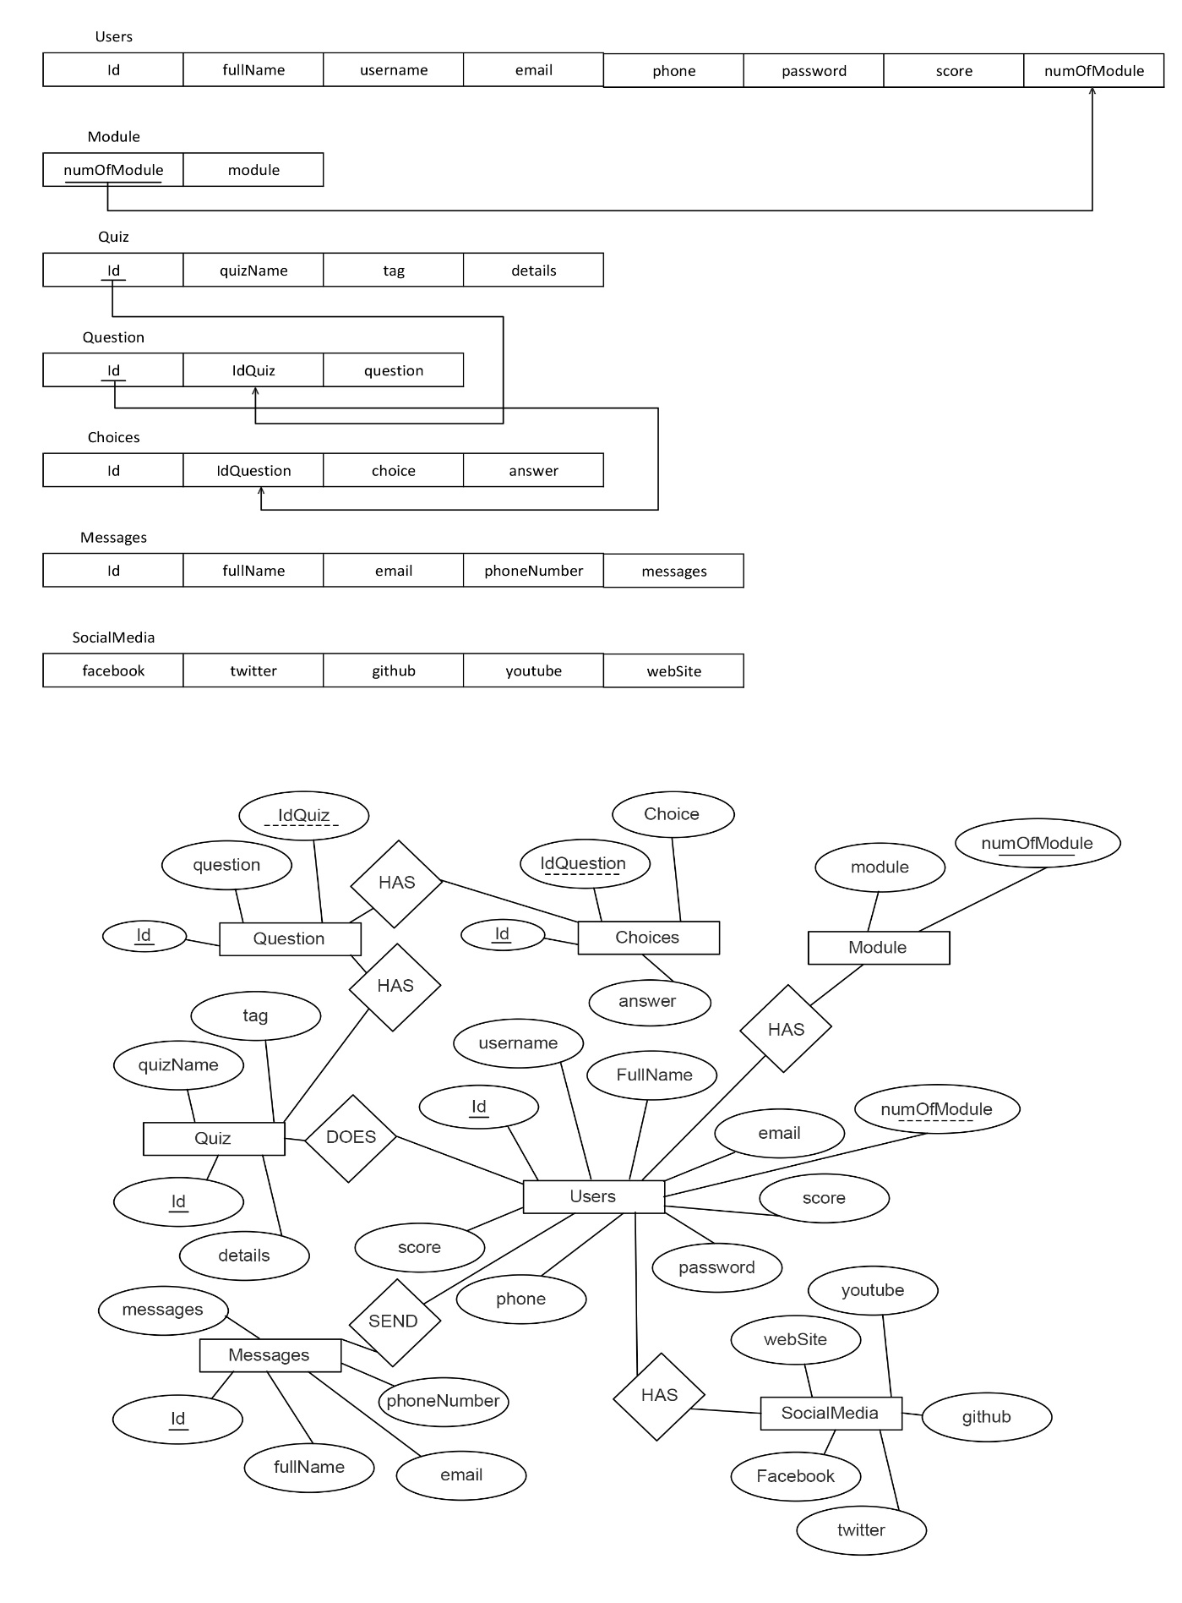

# System Architecture.

# Sequence Diagram(s).

Case 1: View Users.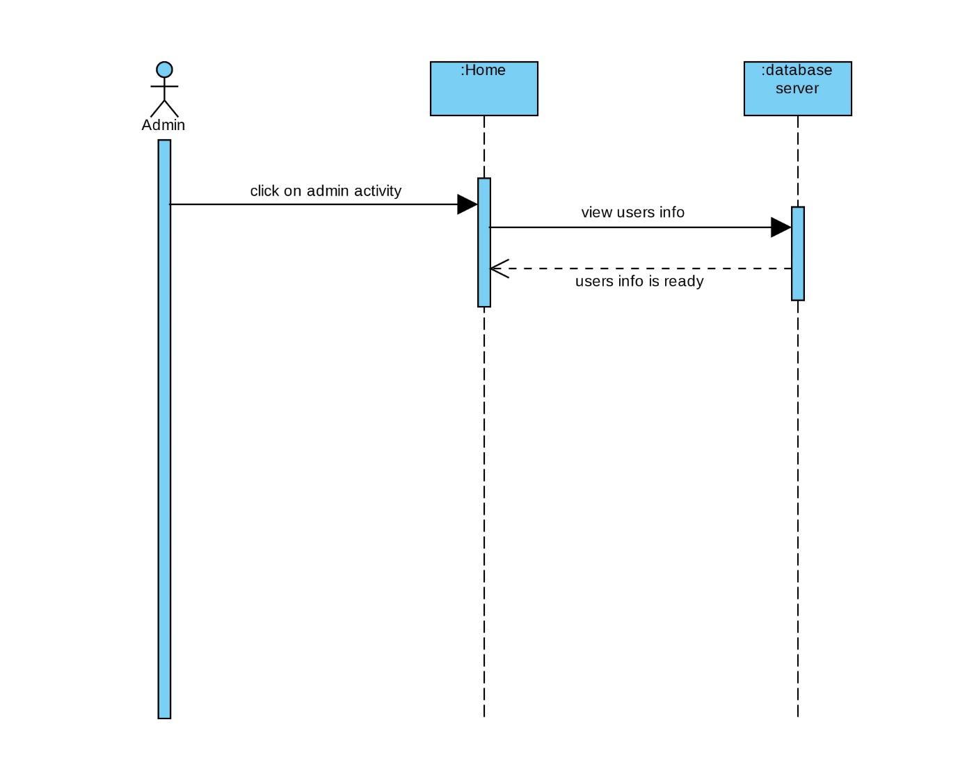

Case 2: View Quizzes. 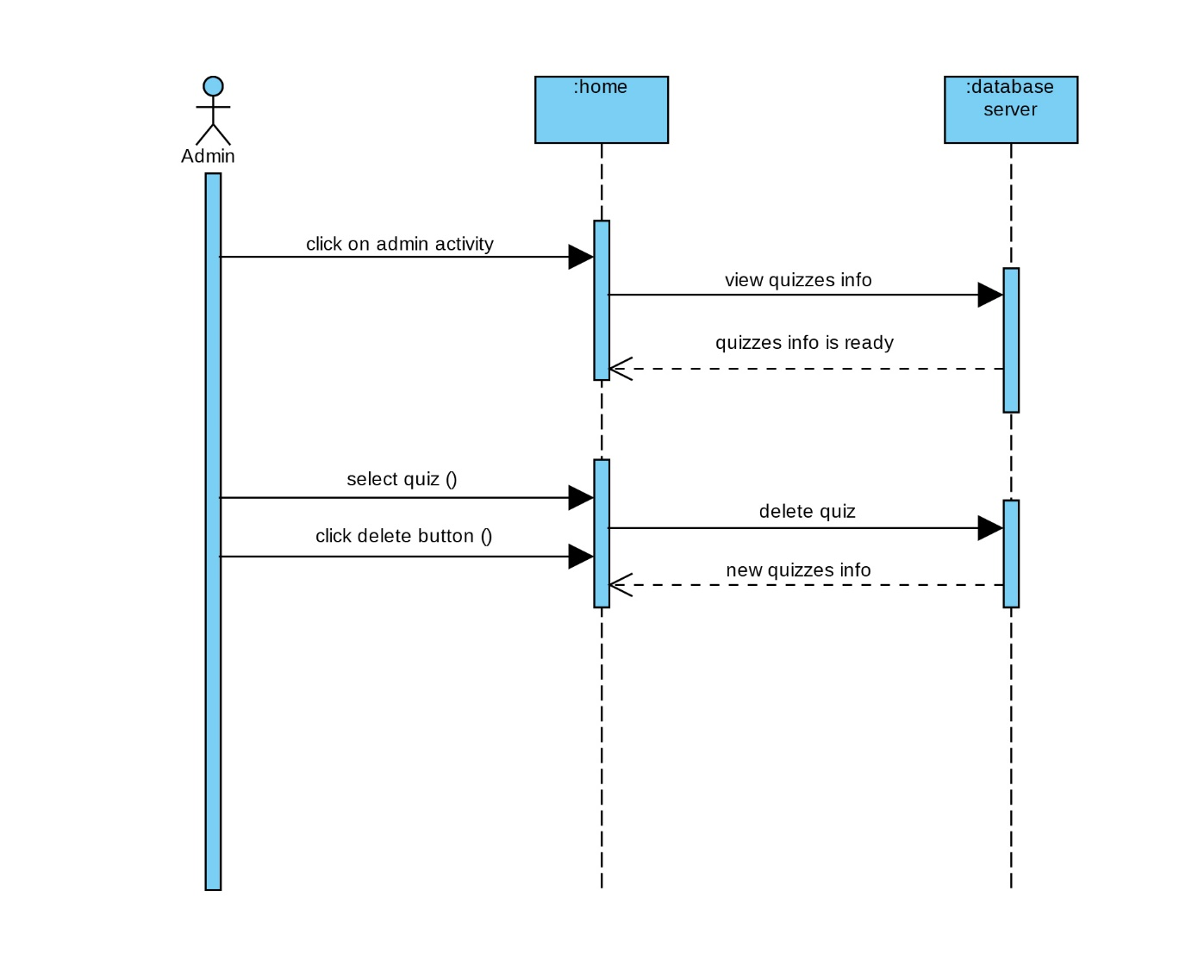Case 3: View Messages.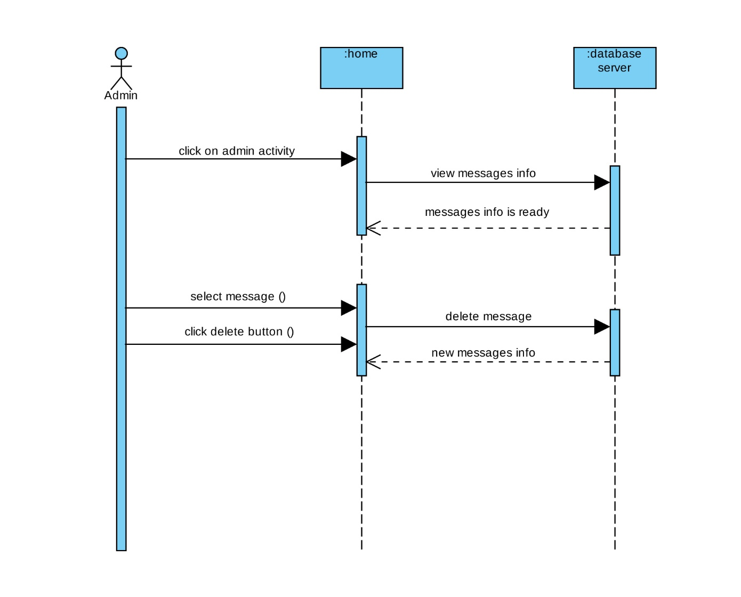

Case 4: Update Profile. 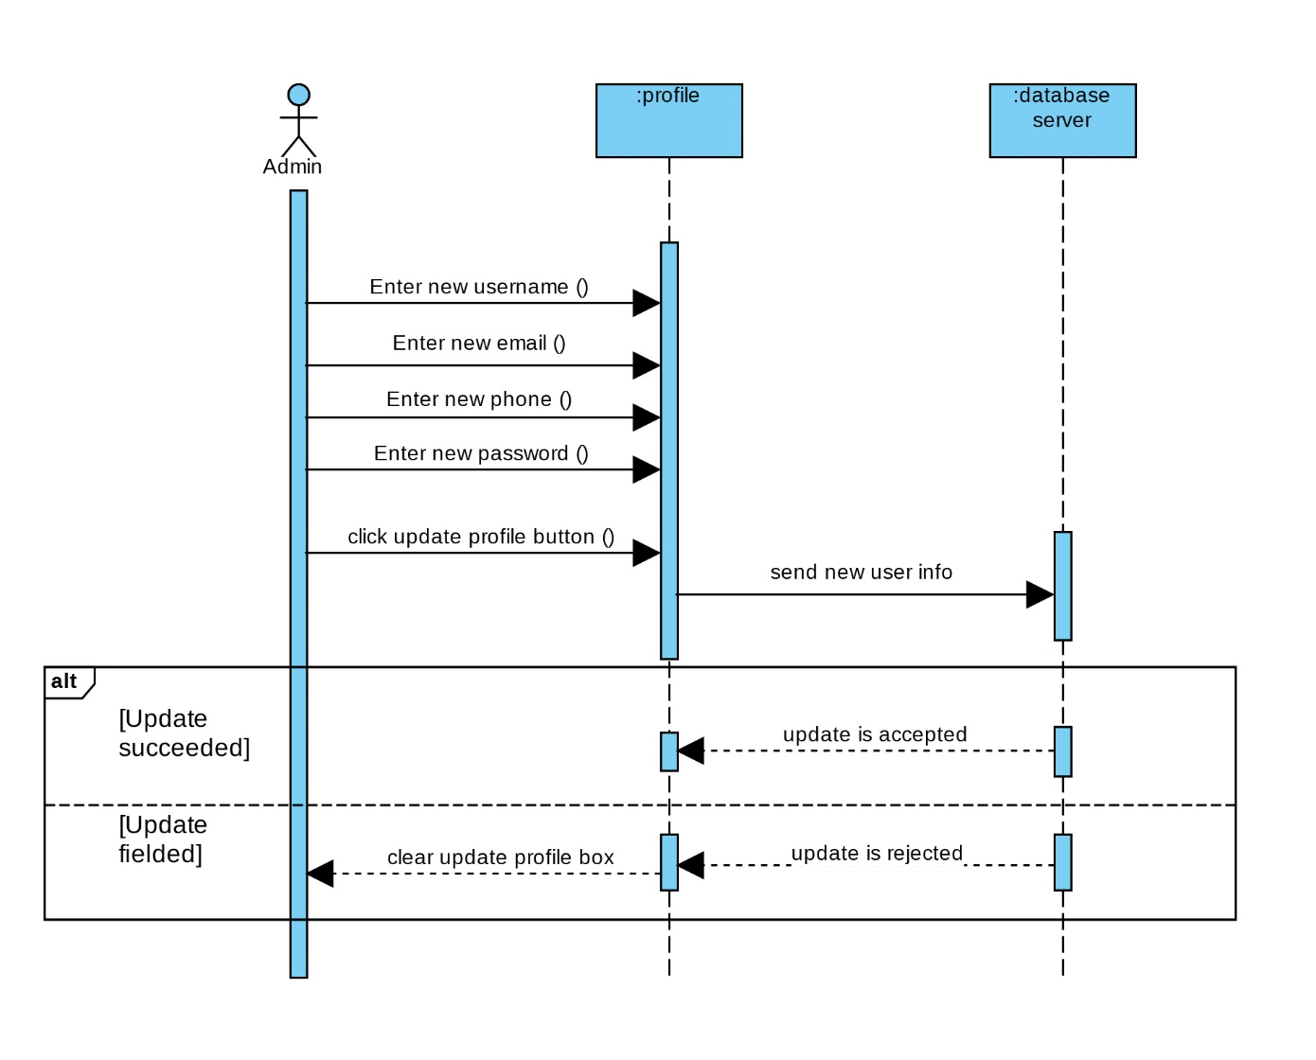

Case 4: Add Quiz.

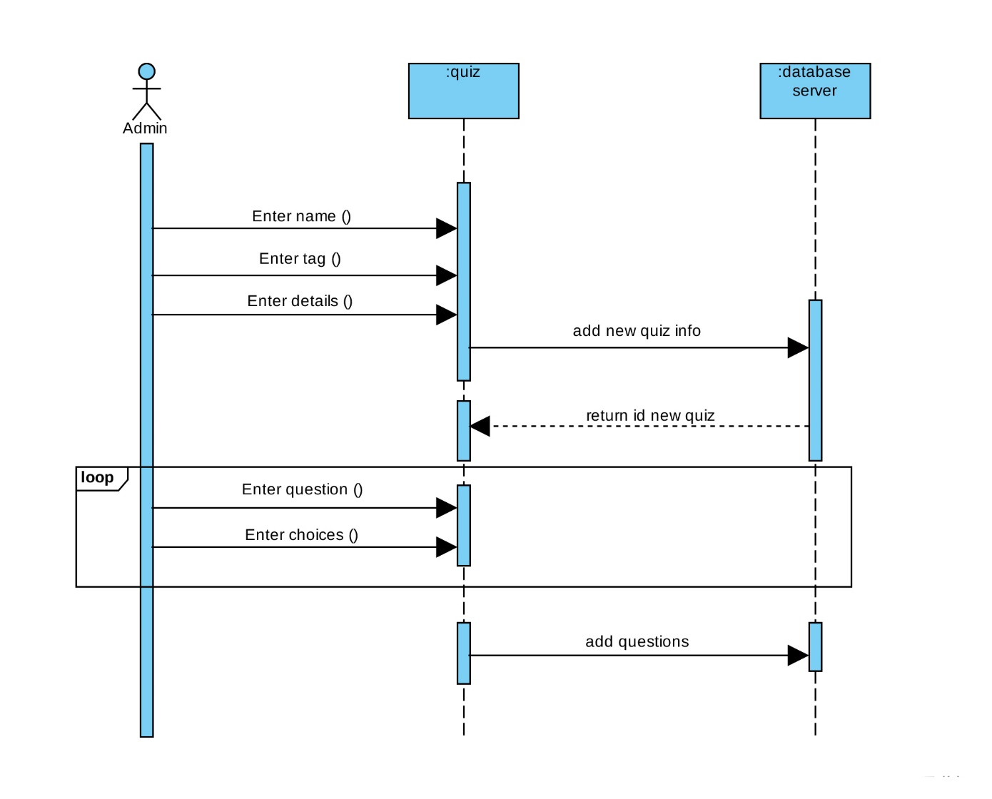

If he/she is User:

Case 1: Send Messages.

Case 2: Update Profile.

Case 3:Do Quiz.

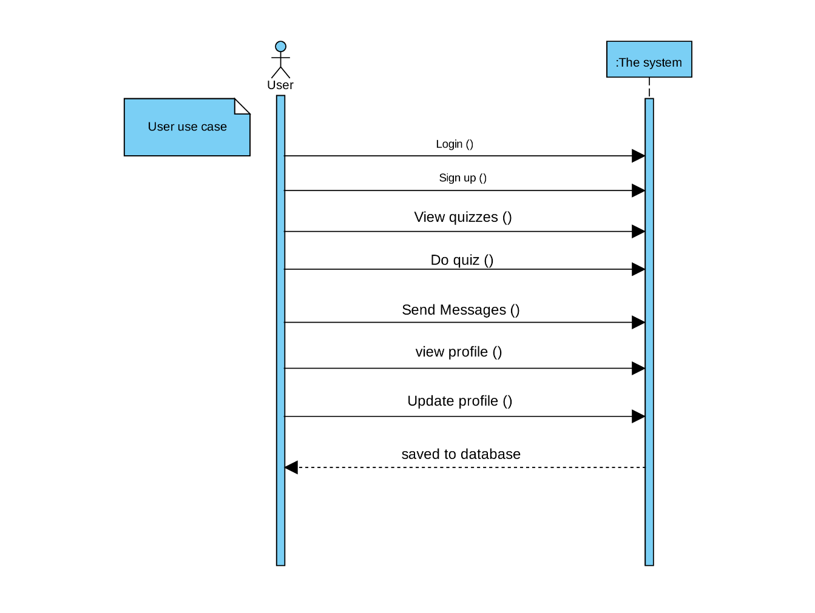

# Collaboration/Communication Diagram(s).

# Class Diagram .

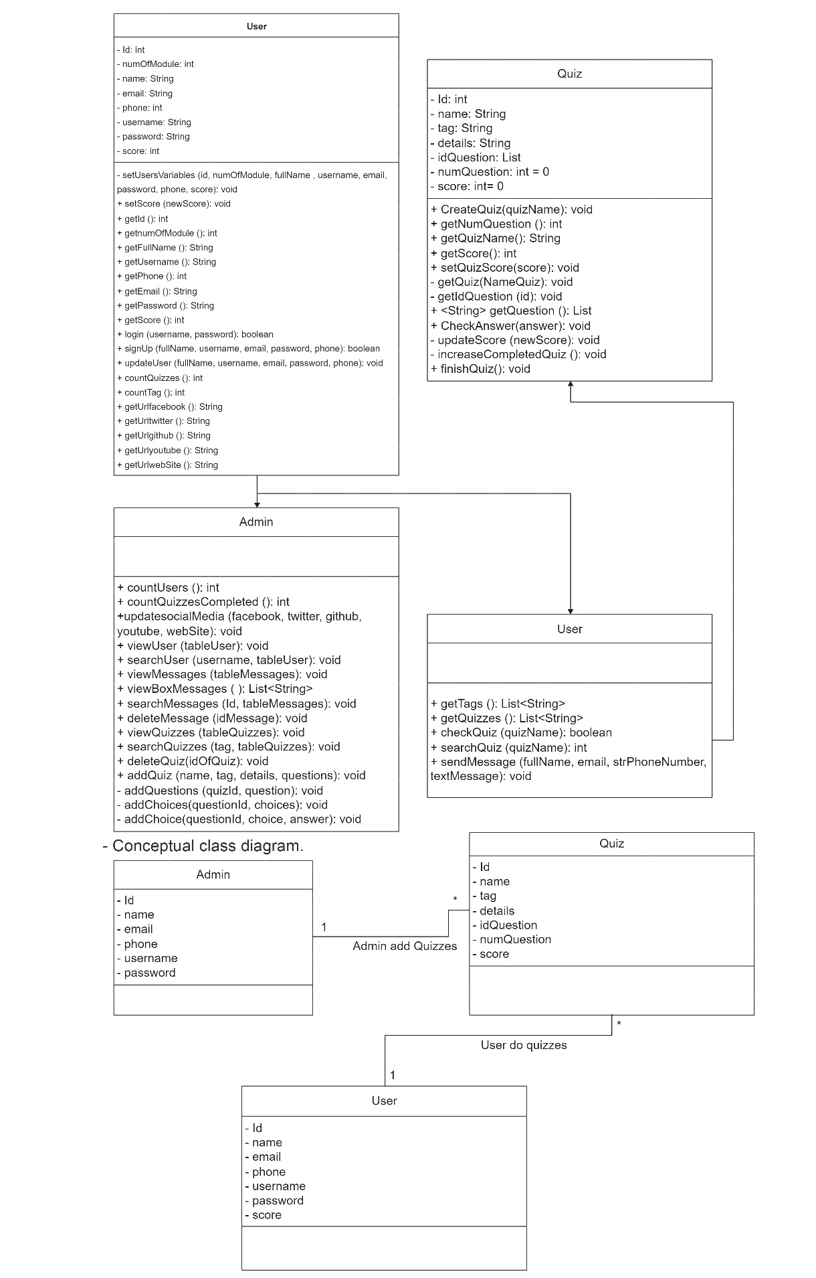

# Package Diagram(s).

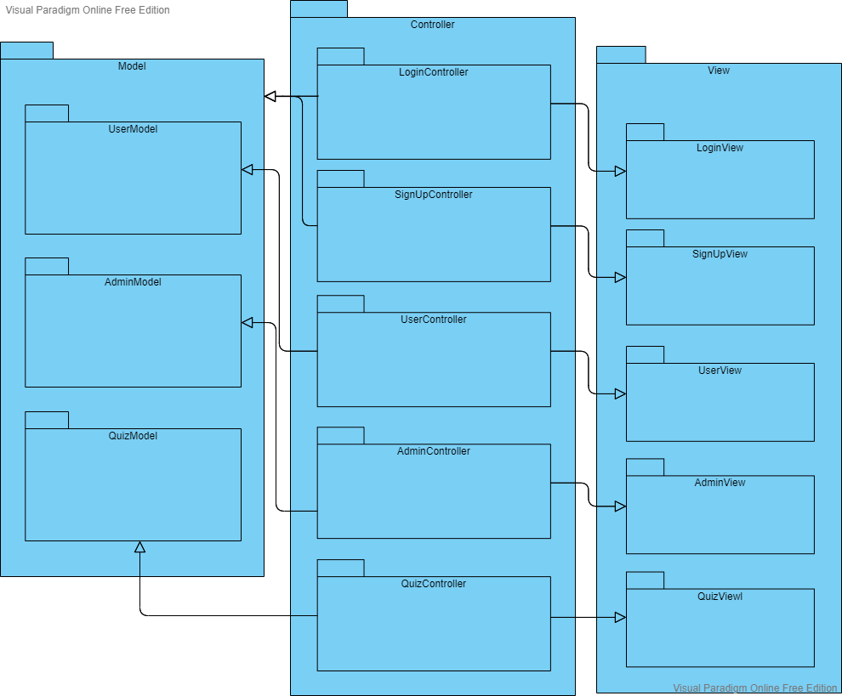

# Design Pattern.

